**Functional Requirement Document**

**for**[**Identify New Bikes**](https://cognizant.tekstac.com/mod/assign/view.php?id=7606)

**Submitted to**

**Cognizant Technology Solutions**

**Submitted by**

K.Kalyani (899488)

O.Ashalatha (899412)

O.vyshnavi (899426)

K.Sahithi(899446)

   K.Jhansi(899389)

**For more information please visit on website:**

**https://www.zigwheels.com/**

**Date of Submission**

APRIL 2021.

**FUNCTIONAL SPECIFICATIONS DOCUMENTATION**

**TEAM HACKTHON EXPRESS**

**JUNE 2021**

**Version 1.0.0**

| VERSION HISTORY | | | | |
| --- | --- | --- | --- | --- |
| VERSION | APPROVED BY | REVISION DATE | DESCRIPTION OF CHANGE | AUTHOR |
|  |  |  |  |  |
|  |  |  |  |  |
|  |  |  |  |  |
|  |  |  |  |  |
|  |  |  |  |  |
|  |  |  |  |  |
|  |  |  |  |  |

**Functional Specifications Document**

**Authorization Memorandum**

I have carefully assessed the Functional Specifications Document for the

IDENTIFY NEW BIKES.

MANAGEMENT CERTIFICATION - Please check the appropriate statement.

______ the document is accepted.

______ the document is accepted pending the changes noted.

______ the document is not accepted.

We fully accept the changes as needed improvements and authorize initiation

of work to proceed. Based on our authority and judgment, the continued

operation of this system is authorized.

_______________________________ _____________________

NAME DATE

Project Manager

_______________________________ _____________________

NAME DATE

Director

*Add other names and roles as necessary.*

TABLE OF CONTENTS

1.0 INTRODUCTION 4

1.1 Purpose 4

1.2 Abbreviations and Acronyms 4

1.3 Refrences 4

1.4 Document conventions 4

2.0 GENERAL DESCRIPTION 5

2.1 Product Context 5

2.2 Overview of Functional Requirements 5

2.3 Overview of Data Requirements 6

2.4 Operating Environment 6

2.5 General Constraints, Assumptions, Dependencies, Guidelines 6

2.6 Design and Implementation Constraints 6

2.7 User Documentation 6

3.0 REQUIREMENTS 7

3.1 External Interface Requirements 7

3.1.1 User Interfaces 7

3.1.2 Hardware Interfaces 7

3.1.3 Software Interfaces 7

3.1.4 Communications Interfaces 8

3.2 Functional Requirements 8

3.2.1 Template for functional requirements 8

3.3 Performance Requirements 14

3.4 Security 14

3.5 Usability 14

3.6 Other Requirements 14

**Appendix A. Analysis Models…………........................................15**

**DISCLAIMER……………………………………………………………..19**

**1.0. INTRODUCTION**

**1.1. Purpose**

Zigwheels is an online marketplace for buying and selling new and used cars in India, founded in 2007.

**1.2. Abbreviations and Acronyms**

* HTML- Hyper Text Markup Language
* CSS -Cascading Style Sheets
* RAM - Random Access Memory.
* GB - Giga Bytes.
* HTTP –Hyper Text Transfer Protocol

**1.3. References**

<https://www.guru99.com/functional-requirement->specification- example.html

**1.4. Document conventions**

Bold faced text has been used to emphasise headings and

Subheadings. Arial font has been used with headings of size 16 and subheadings of size 14 and the description with 12.

# 2.0. GENERAL DESCRIPTION

**2.1. Product Context**

  It is the best car & bike research app in India to buy, sell and compare cars and bikes, be it new or used. It gives you in-depth information, price alerts and offers about new cars, used cars, new motorcycles, second hand bikes and scooters

## 2.2. Overview of Functional Requirements

1. Mouse hover on New Bikes.
2. Click Upcoming Bikes.
3. Select Honda from Select Manufacturer.
4. Display Upcoming Honda Bikes.
5. Back to Browser.
6. Mouse hover on Used Cars
7. Click Chennai.
8. Back to Browser
9. Display Used Cars in Chennai.
10. Back to Browser.
11. Click on Login/Signup.
12. Click on Continue with Google.
13. Click group gifting tab
14. Enter invalid details.

**2.3. Overview of Data Requirements**

* **Input value**: input data should be from different sources.
* **Static value**: a static application or system is required for automation.
* **Output**: expected output data is preferred.

**2.4. Operating Environment**

* **Processor**: Intel core
* **RAM:** 4 GB
* **OS**: windows 10

## 2.5. General Constraints, Assumptions, Dependencies, m

## Guidelines

Each user has an account. Each user has to login using valid credentials. No user can share their login credentials.

## 2.6. Design and Implementation Constraints

* The application has used HTML, CSS, and java script as main technologies.
* HTTP protocols are used to access the web application.
* Since Makemytrip is a web based application, internet connection must be established.
* This web application runs on different browsers.

**2.7. User Documentation**

There are no user manuals, online helps as it is easily understood.

# 3.0. REQUIREMENTS

## 3.1. External Interface Requirements

### 3.1.1. User Interfaces

* All users will see the same page when they enter in this web site.
* When a user tries to login, this page asks email id and password.
* After being authenticated by correct user name and password, user will be directed to their corresponding profile.
* The user interface is simple and easy to understand the terminology.

### 3.1.2. Hardware Interfaces

* No extra hardware interfaces are needed.
* The system will use standard hardware and data communication resources.

**3.1.3. Software Interfaces**

* **Os**: windows 10
* **Web browser**: The system is a web based application; clients need any web browser such as chrome, Firefox, opera, internet explorer. The computer must have an internet connection in order to access with the system.

### 3.1.4. Communications Interfaces

* This system uses communication resources which includes HTTP protocol for communication with web bro and TCP/IP network protocol with HTTP protocol.

## 3.2. Functional Requirements

## 3.2.1. Template for functional requirements

**a. Mouse hover on New Bikes.**

1. **Input:** Mouse hover on New Bikes
2. **Output:** Displaying list of options under New Bikes.

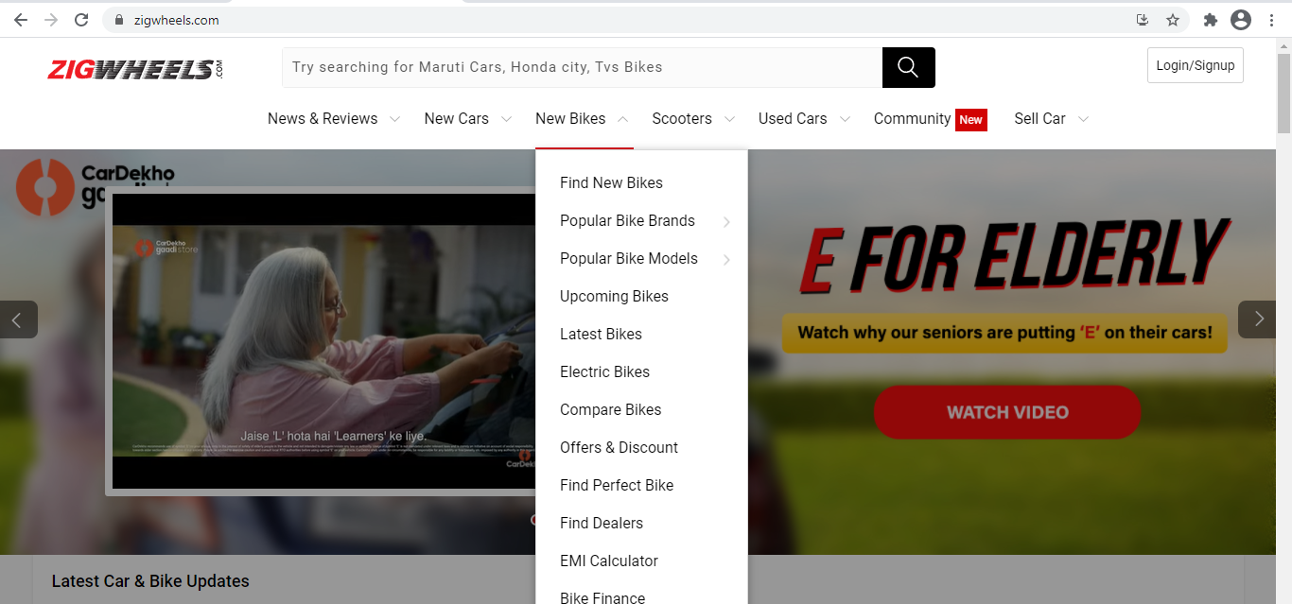

**b. Clicking the Upcoming Bikes**

1. **Input:** Click the Upcoming bikes
2. **Output:** Upcoming Bikes details are displayed.

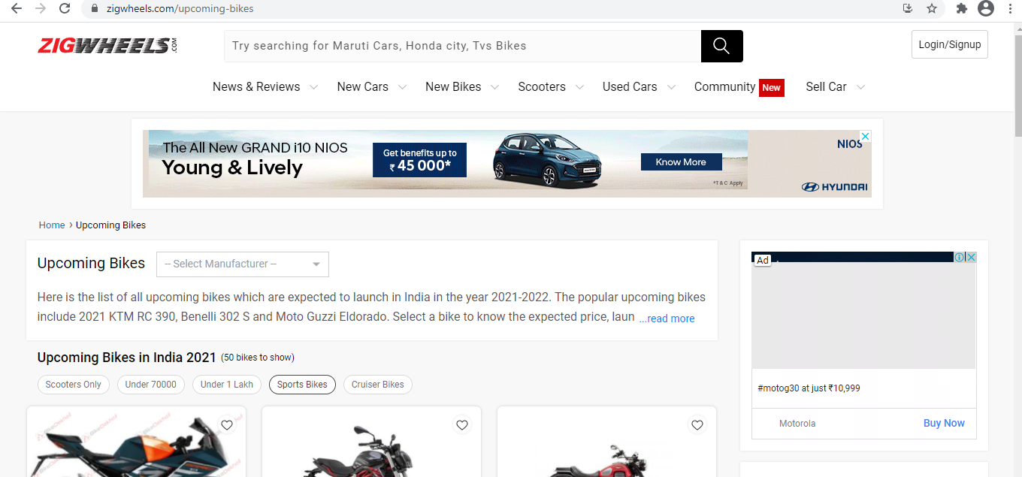

**c. Click View More Option.**

1. **Input:** Select the Honda
2. **Output:** Upcoming Honda Bikes page is displayed.

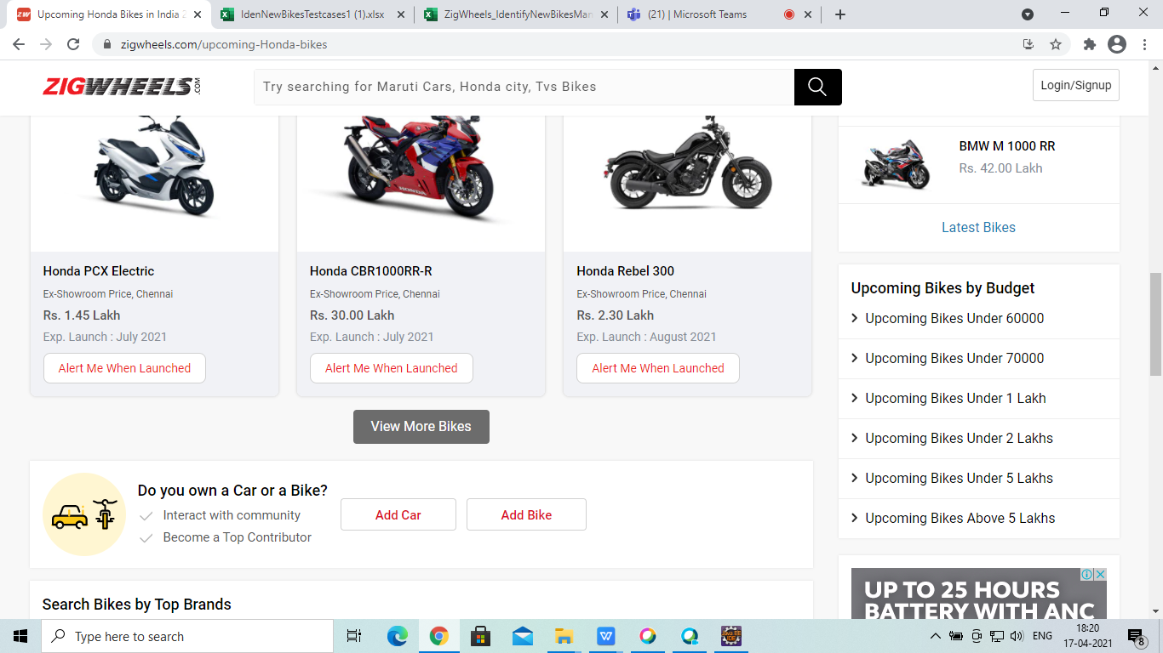

**d. Display Upcoming Bikes**

1. **Input:** Display Upcoming Bikes.
2. **Output:**Upcoming Honda Bikes are displayed.

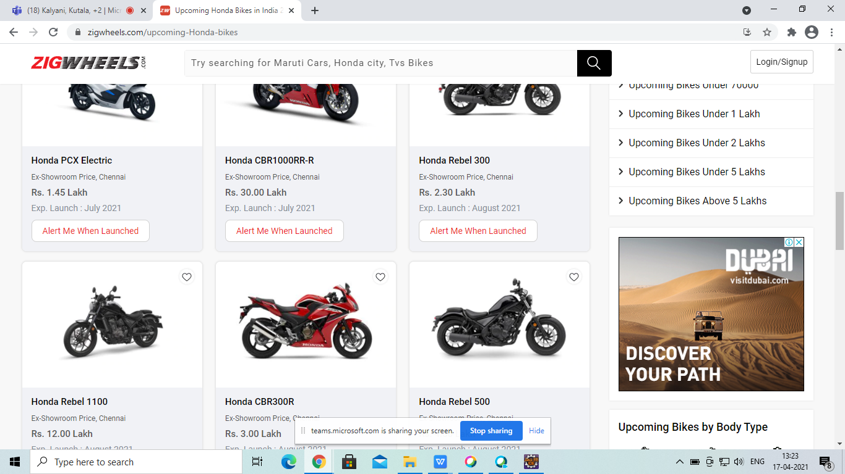

**e.** Back to Browser

**f. Mouse hover on Used Cars**

1. **Input:** Mouse hover on Used Cars.
2. **Output:** The places are displayed.

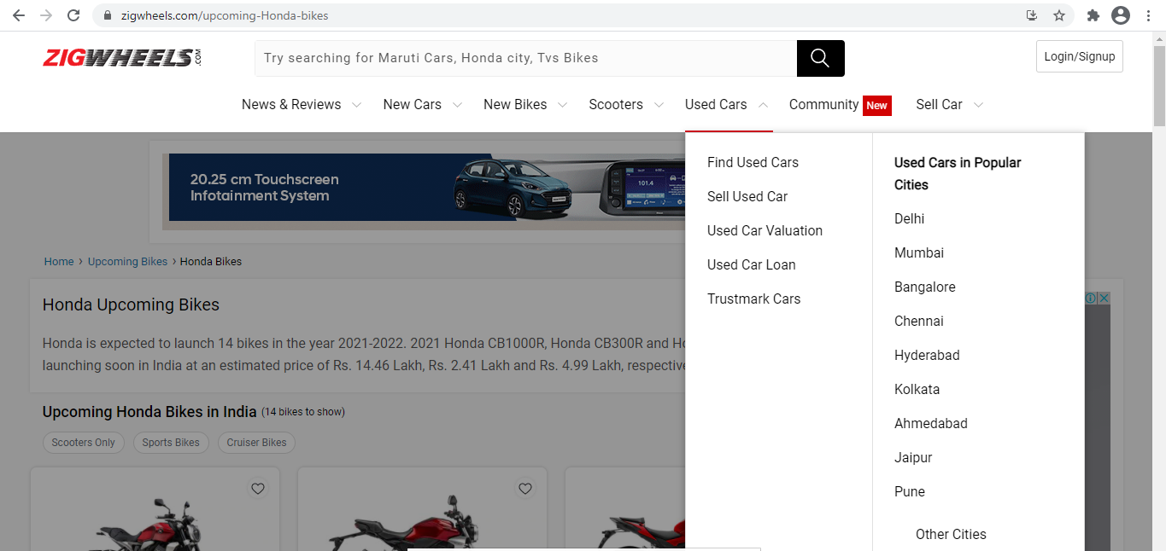

**g. Click Chennai**

1. **Input:** Click the Chennai Option.
2. **Output:** The Popular models are displayed.

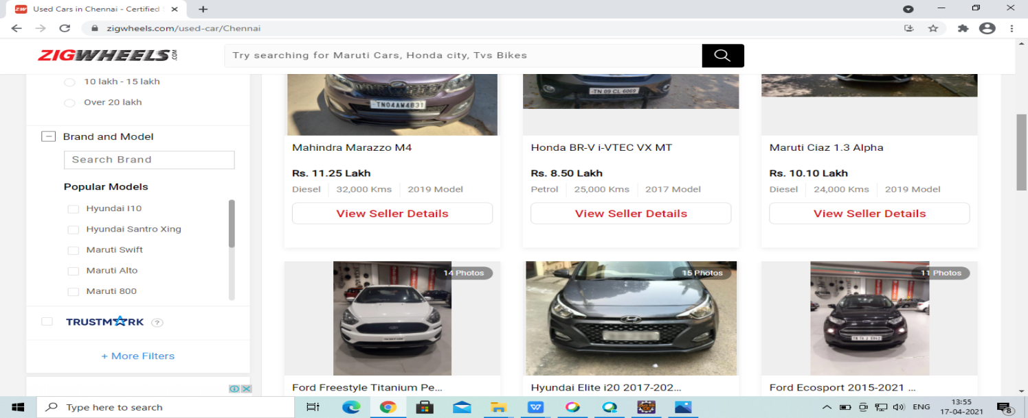

**h. Back to Browser**

**i. Click Login/SignUp**

1. **Input:** Click the Login/SignUp Button.
2. **Output:** Display the Login/Register to Zigwheels page.

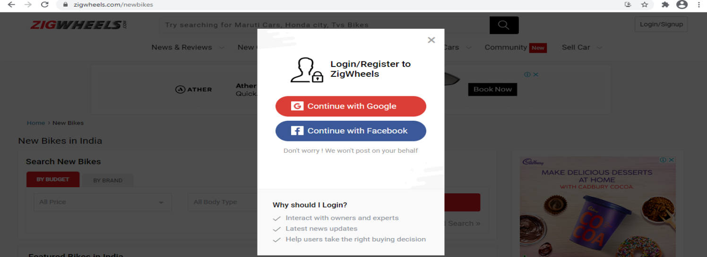

**j. Click the Continue with Google**

1. **Input:** Click the Continue with Google button
2. **Output:** The Signin page is displayed.

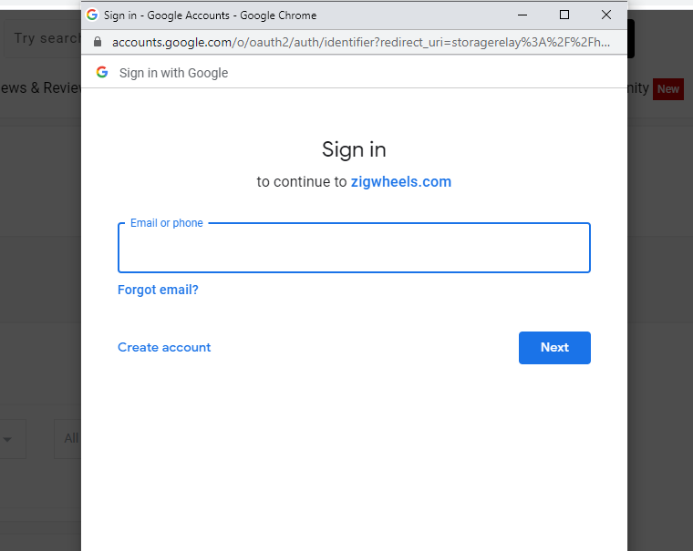

**k. Enter the Login Credentials**

1. **Input:** Enter the Invalid Email
2. **Output:** The Entered email is displayed

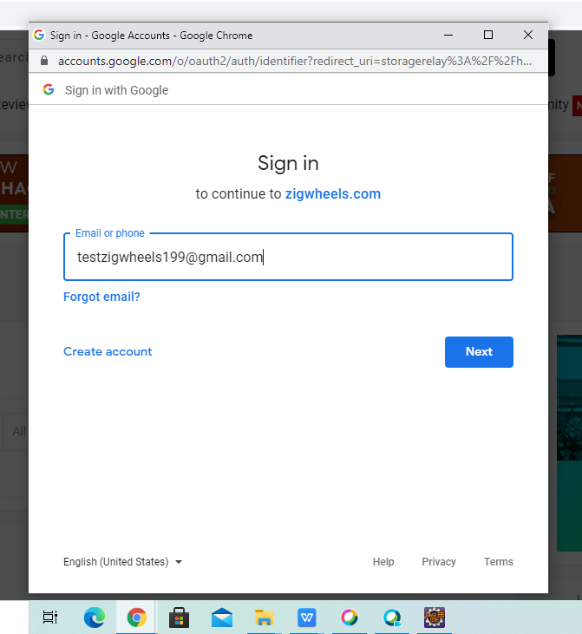

**l.Click the Next**

i. **Input:** Click the Next Button

ii. **Output:** The Error page is displayed

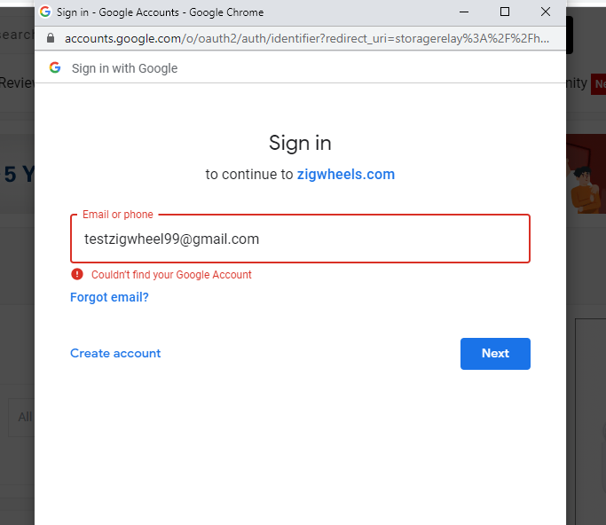

## 

## 3.3. Performance Requirements

The system response time for every interaction conducted by the user should not exceed more than a minimum of 10 seconds. The system should provide a high performance rate when executing users input and should be able to provide response within a short time span usually 50 seconds for a complicated task and 20- 25 seconds for less complicated task.

## 3.4. Security

The system provides authorized access; hence we can only login with valid credentials. Only users with valid login and password can login to their respective logins. If user tries to login with invalid credentials an error message will be displayed.

## 3.5. Usability

The system provides several options which are very easy to use. Terminology is easy so, we can interact with the application very easily.

## 3.6. Other Requirements

**a. Availability:**

The system should be available for access at 24 hours, 7 days a week .Also in the occurrence of any major system malfunctioning, the system should be available in 1 to 2 working days, so that business process is not severely affected.

**b. Error handling:**

Error should be considerably minimized and an appropriate error message that guides the user to recover from the error should be provided. Validation of user’s message is highly essential.

**Appendix A. Analysis Models**

List any attached / referenced documentation such as data flow diagrams, class diagrams, state-transition diagrams, entity-relationship diagrams, etc.

|  |  |  |
| --- | --- | --- |
| **ANALYSIS MODELS** | | |
| **DOCUMENT NAME** | **DESCRIPTION** | **LOCATION** |
| FUNCTIONAL REQUIREMENT DOCUMENT | Upcoming Bikes | https://www.zigwheels.com/ |
| Used Cars |
|
| Login |
|

**DATA FLOW DIAGRAM**

**1. Data Flow for Upcoming Honda Bikes**

Go to the browser

Launch the Application

New Bikes

Select Upcoming Bikes

Select Honda

Click on View More

Display Bike Details

Quit Browser

**2. Data Flow for list of adults in Rooms & Guests of Hotel**

Go to the Browser

Launch the website

Used Cars

Select Chennai

Display Popular Models

Quit Browser

**3. Data Flow for Gift Cards**

Go to the Browser

Launch the Application

Click on Login/Signup Button

Click on Continue with Google

Display Error Message

Email

Invalid

Valid

Invalid

Display Error Message

Password

Valid

Login Successful

Login Successful

Quit Browser

**DISCLAIMER**

Any articles, templates, or information provided by Smart sheet on the website are for reference only. While we strive to keep the information up to date and correct, we make no representations or warranties of any kind, express or implied, about the completeness, accuracy, reliability, suitability, or availability with respect to the website or the information, articles, templates, or related graphics contained on the website. Any reliance you place on such information is therefore strictly at your own risk.